ROUTINE HAEMATOLOGY
TOTAL BLOOD COUNT (TBC)
This should have an appropriate request form; otherwise it is rejected.
The blood sample should be appropriate e.g. in a proper tube, etc.
Haematology analyzer – This machine automatically does TBC. The TBC consists of the total WBC count, differential WBC count (eosinophils, basophils, neutrophils, lymphocytes and monocytes), total RBC count, RBC indices (MCV, MCH, MCHC and PCV) and total platelet count. The results come with their respective reference ranges.
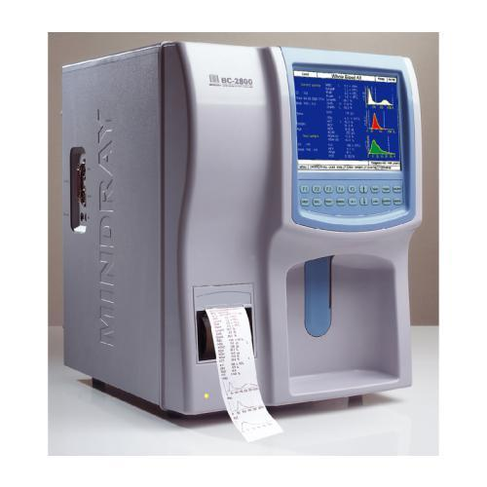HAEMATOLOGY ANALYZER
If the patient sample shows anaemia, infection or leukemia then do a PBF and staining.
ERYTHROCYTE SEDIMENTATION RATE (ESR)
This is done on the sample for TBC (use fresh samples which were collected within 2 hours or refrigerate a sample and use within 6 hours {this however won’t be 100% accurate}).
ESR measures the rate of fall of blood when kept in a tube for 1 hour and this is measured in mm/hr.
This is used as a screening test and used to monitor patients on treatment.
The methods used are:
- Wintrobe ESR tube – This gives results in cm/hr hence the results need to be converted to mm/hr. The reference range for males is 4-9 mm/hr and for females is 5-15 mm/hr.
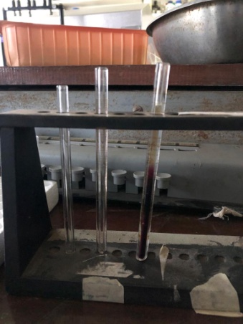
- Westergren ESR tube – The tube has a scale of 0-150 mm. The reference range for males is 0-15 mm/hr and for females is 0-20 mm/hr.
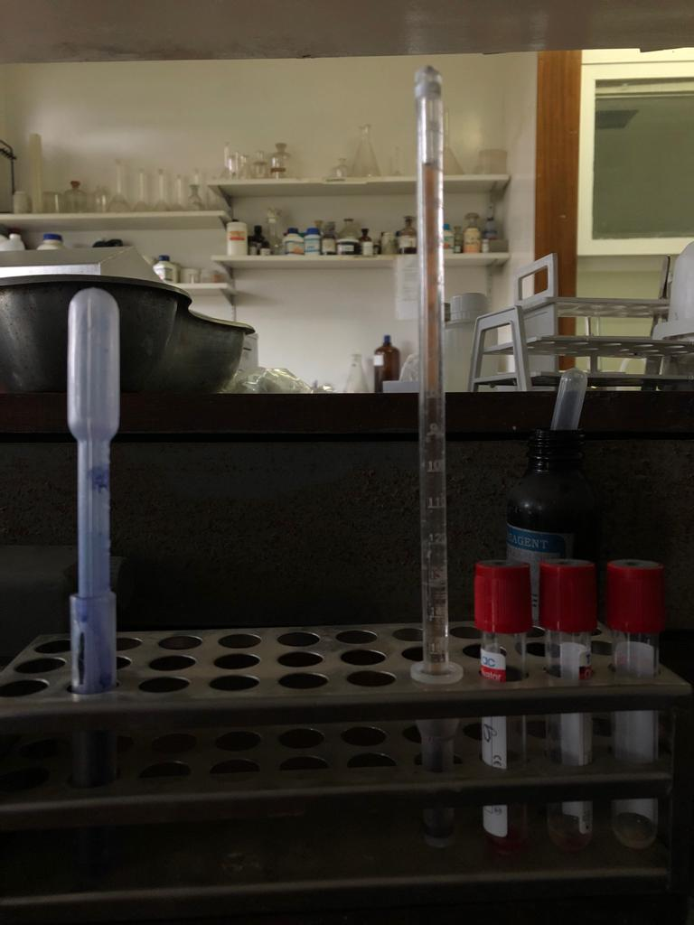
- Automated ESR machine – This gives results in 5 minutes and the reference range is given by the machine.
NB:- Always indicate which method was used with the results as each method has its own reference range.
Low readings are those <4 mm/hr and it is seen in polycythemia, sickle cell and haemoglobin c dx.
High reading is seen in inflammation, TB, multiple myeloma, any anaemia (except for sickle cell anaemia) and leukemia.
BONE MARROW ASPIRATION (BMA)
This requires a doctor, technologist, a nurse and a BMA tray (has Salah and Klima needles)
Do a PBF first (straight and squash) then smears are done on the aspirate
- Iron staining by prussian blue
- Romanowsky staining (Leishman, May-Grunwald, Giemsa, Wrights and Jenna)
Do one PBF, 2 squash and 2 straight
KNH uses MAG (combination of May-Grunwald and Giemsa)
It takes 2-3 days to report the results.
In case of a dry tap for a BMA perform a trephine biopsy
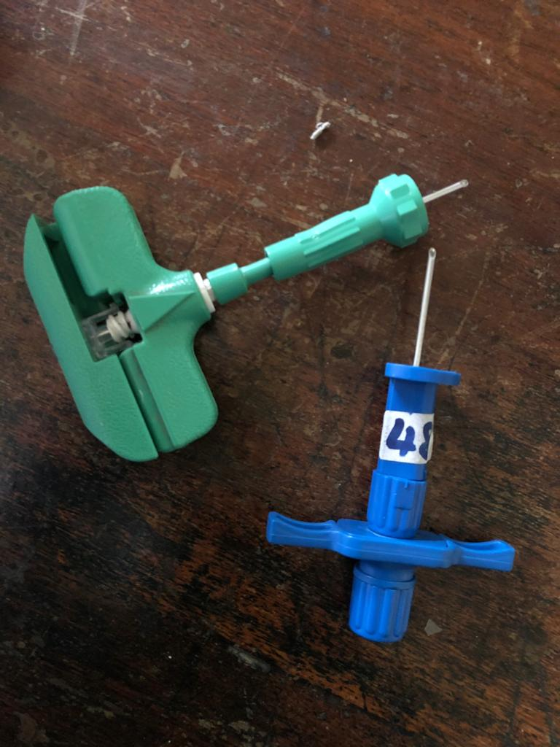
A – SALAH
B - KLIMA
B
A
TREPHINE BIOPSY
Request for trephine tray which has the trephine needles (Jamshidi and Islam – the difference is in the handle)
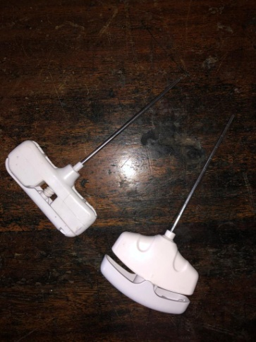
A – Islam
B – Jamshidi
B
A
This procedure cuts a piece of bone.
Procedure – When you reach the bone, don’t puncture it but go clockwise 5-10 times. This cuts the bone – about ½-1 cm. Shake sideways and up and down i.e. to dislodge the biopsy, so the biopsy stays within the needle to bring to the lab
Q. Indications and contraindications of BMA and trephine biopsy
BMA
Indications – IDA (to confirm diagnosis)
Trephine biopsy
Indications – Aplastic anaemia (BMA is a dry tap)

