Non-communicable diseases assignment

- Define the term “non-communicable diseases” (NCD).
Non-communicable diseases (NCD) are medical conditions or diseases that are non-infectious and non-transmissible among people (Kim and Oh, 2013). They are characterised by chronicity, tend to be of long duration and are the result of a combination of genetic, physiological, environmental and behaviours factors (WHO, 2018).
World Health Organization (WHO). Non-communicable diseases. Accessed 30th November 2019. https://www.who.int/news-room/fact-sheets/detail/noncommunicable-diseases

- Classification of non-communicable diseases (NCDs).

- Cardiovascular diseases (CVDs)
  - Hypertension, cerebrovascular accidents (strokes and transient ischemic attacks), coronary artery diseases, peripheral artery diseases and heart failure.
- Chronic respiratory diseases (CRDs)
  - Chronic bronchitis, emphysema, bronchiectasis and asthma.
- Cancers
  - Lung, breast, prostate, oesophageal, colorectal, skin, renal and gastric cancer.
- Renal diseases
  - Diabetic nephropathy, hypertensive nephropathy, chronic kidney disease (CKD) and end-stage renal failure (ESRF).
- Diabetes
  - Type I, II, III and IV diabetes.
Reference: (Ryan et al., 2015)

- What is a risk factor in the context of non-communicable diseases (NCD)?
A “risk factor” refers to any attribute, characteristic, or exposure of an individual which increases the likelihood of developing a noncommunicable disease (WHO, 2003).
World Health Organization, 2003. STEPS: A framework for surveillance. https://www.who.int/ncd_surveillance/en/steps_framework_dec03.pdf

- What are the four common risk factors for non-communicable diseases (NCD)?

- Tobacco use.
- Inappropriate diet.
- Misuse of alcohol.
- Sedentary lifestyle.

World Health Organization, 2003. STEPS: A framework for surveillance. https://www.who.int/ncd_surveillance/en/steps_framework_dec03.pdf

- Using a well-labelled diagram, illustrate the causal-chain of non-communicable diseases (NCDs).

(Mayige, 2016)

The causal-chain of NCDs is employed in the WHO step-wise approach to the surveillance of NCDs (question 8 ii).

- Describe the concept of “commonality of risk factor” and the public health application of the same.
This refers to the state of sharing of a risk factor by two or more noncommunicable diseases (NCDs). For example, tobacco smoking is a known risk factor for lung cancer, coronary artery disease, chronic bronchitis and diabetes mellitus. Therefore, tobacco smoking is a risk factor common to all these diseases.
In the context of public health, gaining a greater understanding and taking greater account of the interconnected and overlapping relationships between common risk factors and common NCDs may facilitate more appropriate and targeted risk reduction. Further, understanding the commonality of risk factors provides the potential for targeted risk reduction to simultaneously impact multiple noncommunicable disease areas. (Peters et al., 2019). Surveillance of those major risk factors which are known to be common to several major NCDs, and which are found to be predictive of disease occurrence should be given a high priority (WHO, 2003).

- Social determinants of health

  - Define the term “social determinants of health”.
The social determinants of health are the conditions in which people are born, grow, live, work and age. These circumstances are shaped by the distribution of money, power and resources at global, national and local levels. They include intangible factors such as political, socioeconomic, and cultural constructs, as well as place-based conditions including accessible healthcare and education systems, safe environmental conditions, well-designed neighbourhoods, and availability of healthful food.
  - Using the conceptual framework of social determinants of health (SDH), describe its application in the prevention and control of non-communicable diseases (NCDs).
The SDH conceptual framework outlines how the social, economic and political mechanisms give rise to a set of socioeconomic positions, whereby populations are stratified according to income, education, occupation, gender, race/ethnicity and other factors; these socioeconomic positions in turn shape specific determinants of health status (intermediary determinants) reflective of people’s place within social hierarchies; based on their respective social status, individuals experience differences in exposure and vulnerability to health-compromising conditions.
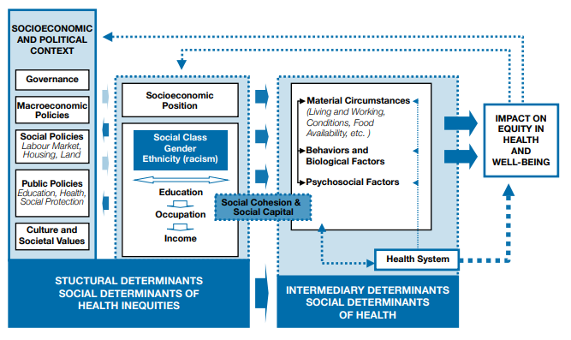

A number of these SDH are common to several NCDs. For instance, socio-economic status is a key determinant of health status and many indicators have been developed to describe the social structure for public health purposes. The multidimensional understanding of the determinants of disease requires targeting of various preventive actions to different levels of causation. For instance, at the physiological level, clinical (pharmacological) interventions may be appropriate whereas at the level of social structure, the intervention might be directed at alleviation of poverty. Community interventions aimed at changing the pattern of behaviours that predict the occurrence of disease - for example, physical inactivity or smoking - are in midway in the scale (WHO, 2003).
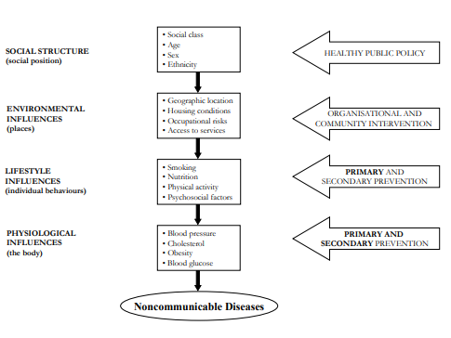

- Disease surveillance.

- Definition.
This term is borrowed from a French word meaning “to watch over”.
The original definition of surveillance was “the continued watchfulness over the distribution and trends of incidence through systematic collection, consolidation, and evaluation of morbidity and mortality reports and other relevant data” directly linked to timely regular dissemination of the results to “those who need to know” (Langmuir, 1963)
In the 21st World Health Assembly (WHA) of 1968 later modified this definition to “systematic collection and use of epidemiologic information for the planning, implementation, and assessment of disease control” (WHO, 1968)
Langmuir, A. D. The surveillance of communicable diseases of national importance. The New England Journal of Medicine 268, 182-192. 1963.
World Health Organization. Report of the technical discussions at the twenty-first World Health Assembly on "national and global surveillance of communicable diseases". A2 1. 18-5- 1968. Geneva, WHO.
- Components of WHO step-wise surveillance of risk factors of NCDs.
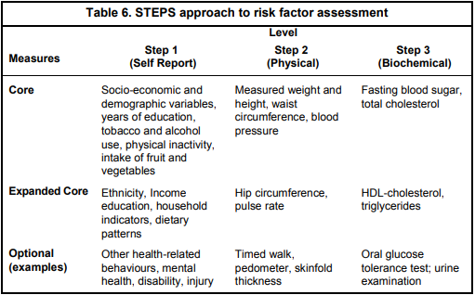
The WHO-STEPwise approach to surveillance (STEPS) is the WHO-recommended NCD surveillance tool. This framework unifies all WHO approaches to defining core variables for population-based surveys, surveillance and monitoring instruments. The goal is to achieve data comparability over time and between countries. STEPS offer an entry point for low- and middle-income countries to get started in NCD activities. The recommended surveillance measures are categorised according to the degree of complexity and cost in obtaining the data, starting with questionnaire-based assessment to biochemical measurements. The main components are as outlined below.

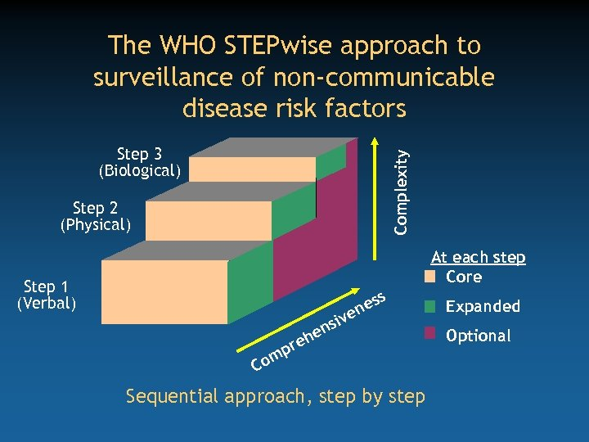

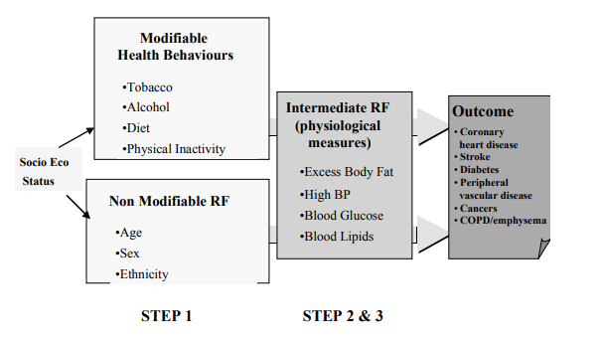

- Rationale for the selection of risk factors for surveillance.
The rationale for the selection of a core risk factor for disease surveillance include the following:
- They have the greatest impact on NCD mortality and morbidity.
- There is evidence that their modification is possible and effective in primary prevention.
- The measurement has some validity.
- The measurement can be applied in both developed and developing countries, and comparison across countries will be meaningful.
- The measurement can be obtained while following appropriate ethical standards.

- The association between tobacco use and:

- Cancers
Smoking is a major risk factor for the development of cancers of the lung, larynx, mouth, oesophagus, urinary bladder, kidney, liver, stomach, pancreas, colon and rectum, and cervix, as well as acute myeloid leukaemia. Summary of evidence supporting this association was obtained from published systematic reviews and meta-analysis, and presented in the tables below.
Cancer | Study | Number of participants | Strength of association
Lung | Lee et al., 2012 | 287 studies (n=326,317 participants | Current smoker |  | RR= 8.43, (95% CI 7.63, 9.31)
Lung | Lee et al., 2012 | 287 studies (n=326,317 participants | Ex-smokers |  | RR= 4.30, (95% CI 3.93, 4.71)
Lung | Lee et al., 2012 | 287 studies (n=326,317 participants | Ever smoking |  | RR= 5.50, (95% CI 5.07, 5.96)
Lung | Gandini et al., 2008 | 21 studies | Current smoker |  | RR= 8.96 (95% CI 6.73, 12.1)
Lung | Gandini et al., 2008 | 21 studies | Former smoker |  | RR= 3.85 (95% CI 2.77, 5.34)
Larynx | Gandini et al., 2008 | 10 studies | Current smoker | RR= 6.98 (95% CI 3.14, 15.5)
Larynx | Gandini et al., 2008 | 10 studies | Former smoker | RR= 4.65 (95% CI 3.35, 6.45)
Prostate | Islami et al., 2014 | 51 studies (4,082,606 participants) | Current smoker | RR= 1.24 (95% CI 1.18, 1.31)
Prostate | Islami et al., 2014 | 51 studies (4,082,606 participants) | Former smoker | RR= 1.06 (95% CI 1.00, 1.12)
Larynx | Gandini et al., 2008 | 10 studies | Current smoker | RR= 6.76 (95% CI 2.86, 16.0)
Larynx | Gandini et al., 2008 | 10 studies | Former smoker | RR= 2.28 (95% CI 0.95, 5.50)
Pancreas | Iodice et al., 2008 | 82 studies (>7,000,000 participants) | Current smoker | RR= 1.74 (95% CI 1.61, 1.87)
Pancreas | Iodice et al., 2008 | 82 studies (>7,000,000 participants) | Former smoker | RR= 1.2 (95% CI 1.11, 1.29)
Oral cavity | Gandini et al., 2008 | 21 studies | Current smoker | 3.43 (2.37, 4.94)
Oral cavity | Gandini et al., 2008 | 21 studies | Former smoker | 1.40 (0.99, 2.00
Esophagus | Gandini et al., 2008 | 20 studies | Current smoker | 2.50 (2.00, 3.13)
Esophagus | Gandini et al., 2008 | 20 studies | Former smoker | 2.03 (1.77, 2.33)

- Diabetes mellitus
Observational studies have linked various smoking behaviours (active smoking, passive smoking, and smoking cessation) with risk of type 2 diabetes. A summary of findings table regarding the strength of association between tobacco smoking and risk of diabetes is presented below. The data has been obtained from systematic reviews and meta-analyses of population-based studies.
Study | Number of participants | Strength of association
Pan et al., 2015 | 88 studies (n= 5,898, 795 participants | Current smokers | RR= 1.37 (95% CI 1.33, 1.42)
Pan et al., 2015 | 88 studies (n= 5,898, 795 participants | Former smokers | RR= 1.14 (95% CI 1.10, 1.18)
Akter et al., 2017 | 22 studies (n= 343,573 participants) | Current smokers | RR= 1.38 (95% CI 1.28, 1.49)
Akter et al., 2017 | 22 studies (n= 343,573 participants) | Former smokers | RR= 1.19 (95% CI 1.09, 1.31)
Yuan et al., 2019 | 20 studies (n= 5,077,289 participants) | Ever smoked; RR= 1.02 (95% CI 0.98, 1.04)

- Chronic obstructive lung disease (COPD)
Chronic obstructive pulmonary disease (COPD) is a major and growing cause of morbidity and mortality worldwide. A summary of findings table regarding the strength of association between tobacco smoking and risk of COPD is presented below. The data has been obtained from systematic reviews and meta-analyses of population-based studies.

Study | Number of participants | Strength of association
Forey et al., 2011  (COPD) | 133 studies | Current smokers | RR= 3.51 (95% CI 3.08, 3.99)
Forey et al., 2011  (COPD) | 133 studies | Former smokers | RR= 2.89 (95% CI 2.63, 3.17)
Forey et al., 2011  (Chronic bronchitis) | 101 studies | Current smokers | RR= 3.41 (95% CI 3.13, 3.72)
Forey et al., 2011  (Chronic bronchitis) | 101 studies | Former smokers | RR= 2.69 (95% CI 2.5, 2.9)
Forey et al., 2011  (Emphysema) | 28 studies | Current smokers | RR= 4.87 (95% CI 2.83, 3.41)
Forey et al., 2011  (Emphysema) | 28 studies | Former smokers | RR= 4.51 (95% CI 3.08, 3.99)
Wang et al., 2015 | 24 studies (93, 045 participants) | Ever smoked RR= 2.90 (95% CI 2.22, 3.80)

- Cardiovascular diseases (CVDs).
To date, numerous studies have reported associations between tobacco smoking and the risk of cardiovascular diseases (CVDs). A summary of findings table regarding the strength of association between tobacco smoking and risk of COPD based on systematic reviews and meta-analyses of population-based studies is presented below.

CVD | Study | Number of participants | Strength of association
Heart failure | Lee and Son, 2019 | 7 studies (n=47,585 participants) | Current smoker |  | HR= 1.609 (95%CI 1.470–1.761)
Heart failure | Lee and Son, 2019 | 7 studies (n=47,585 participants) | Ex-smokers |  | HR= 1.209 (95% CI 1.084–1.348)
Heart failure | Aune et al., 2018 | 26 studies | Current smoker |  | RR= 1.75 (95% CI: 1.54–1.99)
Heart failure | Aune et al., 2018 | 26 studies | Former smoker |  | RR= 1.16 (95% CI: 1.08–1.24)
Coronary artery disease | Huxley and Woodward, 2011 | 26 studies (3, 912, 809) | Current smoker | RR= 1·25 (95% CI 1·12–1·39)
Sudden cardiac death | Islami et al., 2014 | 51 studies (4,082,606 participants) | Current smoker | RR= 3.06 (95% CI 2.46–3.82)
Sudden cardiac death | Islami et al., 2014 | 51 studies (4,082,606 participants) | Former smoker | RR= 1.38 (95% CI 1.20–1.60)
Coronary artery disease | Aune et al., 2018 | 12 studies | One cigarrete | RR= 1.48 (95% CI 1.30- 1.69
Coronary artery disease | Aune et al., 2018 | 12 studies | Five cigarretes | RR= 1.58 (95% CI 1.39- 1.80)
Coronary artery disease | Aune et al., 2018 | 12 studies | 20 cigarretes | RR= 2.04 (95% CI 1.86, 2.24)
Stroke | Pan et al., 2019 | 14 studies (303,134 participants) | Current smoker | OR= 1.92 (95% CI 1.49-2.48)
Stroke | Pan et al., 2019 | 14 studies (303,134 participants) | Former smoker | OR= 1.30 (95% CI: 0.93-1.81)
Stroke | Shinton and Beevers, 1989 | 32 studies | Current smoker | RR= 1.5 (95% CI 1.4- 1.6)
Peripheral artery disease | Lu et al., 2014 | 55 studies | Current smoker | OR= 2.71 (95% CI 2.28- 3.21)
Peripheral artery disease | Lu et al., 2014 | 55 studies | Former smoker | OR= 1.67 (95% CI 1.54- 1.81)

- Define the following epidemiological terms.

- Risk: It is a measure of the probability than an individual in the population as whole will experience of an outcome event. It is calculated as the number of new cases divided by the total population-at-risk at the beginning of the follow-up period.
- Rate: It is the number of new cases of a health outcome divided by the total person-time-at-risk for the population. Person-time is calculated by the sum total of time all individuals remain in the study without developing the outcome of interest (the total amount of time that the study members are at risk of developing the outcome of interest).
- Odds: odds of an event represent the ratio of the (probability that the event will occur) / (probability that the event will not occur). For example, if the probability of the event occurring = 0.80, then the odds are 0.80 / (1-0.80) = 0.80/0.20 = 4 (i.e., 4 to 1).
- Absolute risk: This is the likelihood of outcome event occurring within a single group of individuals.
- Relative risk: This is the ratio of the absolute risk of an outcome event occurring between two groups, hence the term relative. If the absolute risk of lung cancer in smokers was 5.3, while that in the non-smokers was 0.4, then the relative risk of lung cancers in smokers compared with non-smokers will be 5.3/0.4= 13.25. Relative risk is also referred to as the risk ratio (RR).
- Attributable risk: It is the portion of disease rate attributable to the exposure factor in the epidemiologic context. In other words, the attributable risk is the extent to which the incidence of disease would be reduced had the individuals not been exposed to the factor. This is the difference between the absolute risk of an outcome event between the exposed and the unexposed group divided by the absolute risk in the exposed group. Using the example in (e) above, the attributable risk of lung cancer due to smoking= (5.3-0.4)/5.3*100= 0.92. This means that more than 92% of the lung cancers were due to exposure (smoking).
- Number needed to treat/prevent (NNT/NNP): NNT is the average number of patients who need to be treated to prevent one additional adverse outcome. the inverse of the absolute risk difference and can thus simply be calculated by dividing 1 by the absolute risk difference. For example, suppose one aims to study a new drug and the study results show that the risk of the disease was 0.14 (14%) in the group exposed to the new drug and 0.18 (18%) in the control group unexposed to the drug. The absolute risk reduction would then be 0.18 − 0.14 = 0.04, yielding an NNT of 1/0.04 = 25. This means that 25 patients need to be treated with the new drug to prevent one new case of the disease, which can be considered as a good result that supports the use of the new drug.
- Odds ratio: This ss a measure of association between an exposure and an outcome. The OR represents the odds that an outcome will occur given a particular exposure, compared to the odds of the outcome occurring in the absence of that exposure. Odds ratios are most commonly used in case-control studies; however, they can also be used in cross-sectional and cohort study designs as well (with some modifications and/or assumptions).
- P-value: is the probability of obtaining the observed results of a test, assuming that the null hypothesis is correct. It is the level of marginal significance within a statistical hypothesis test representing the probability of the occurrence of a given event.
- 95% confidence interval: This is a range of values that you can be 95% certain contains the true point estimate (mean or proportion) of the population.

